


Foundations of Programming
Assignment No. : 10

PROBLEM STATEMENT:
Write a program in C to simulate a simple calculator that performs basic arithmetic operations such as addition, subtraction, multiplication, and division. The calculator should also perform special operations like computing xʸ (power) and x! (factorial).

OBJECTIVE:
• To understand the use of switch-case statements in C.
• To perform basic arithmetic and special mathematical operations.
• To enhance problem-solving skills using menu-driven programs.

THEORY:
A calculator is a basic computing device used to perform arithmetic operations. In C programming, a simple calculator can be implemented using conditional or switch-case statements. Arithmetic operations like addition, subtraction, multiplication, and division are fundamental operations. Special operations such as power (xʸ) and factorial (x!) require loops for repeated calculations.

PLATFORM:
Linux

ALGORITHM:
- Start
- Accept the choice of operations for user and store in n
- Accept 2 numbers and store in a and b
- Use switch-case based on n
- If n is 1, perform Addiction and display sum
- If n is 2, perform Subtraction and display Difference
- If n is 3, perform Multiplication and display Product
- If n is 4, perform Division and display Quotient
- If n is 5, find the power of a w.r.t. b and display the result
- If n is 6, find the factorial of a and display
- If no cases match, display Invalid Input
- Stop

C PROGRAM:
#include <stdio.h>
#include <math.h>
int main()
{
int n;
float a,b,c;
printf("1.Addition \n 2.Subtraction \n 3.Multiplication \n 4.Division \n 5.Power(x^y) \n 6.Factorial \n");
printf("Enter your choice: ");
scanf("%d",&n);
printf("Enter two numbers: ");
scanf("%f %f",&a,&b);
switch(n)
{
case 1:
printf("Sum is %f",(a+b));
break;
case 2:
printf("Difference is %f",(a-b));
break;
case 3:
printf("Product is %f",(a*b));
break;
case 4:
printf("Quotient is %f",(a/b));
break;
case 5:
printf("Result of %f ^ %f is %f",a,b,(pow(a,b)));
break;
case 6:
float fact=1;
for(int i=1;i<=a;i++)
{
fact*=i;
}
printf("Factorial of %f is %f",a,fact);
break;
default:
printf("Invalid Input");
}
}

INPUT:
User selects an operation from the menu and enters required values.
Example Input:
Choice: 1
Numbers: 10 20
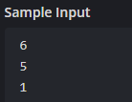

OUTPUT:
Example Output:
Result = 30.00
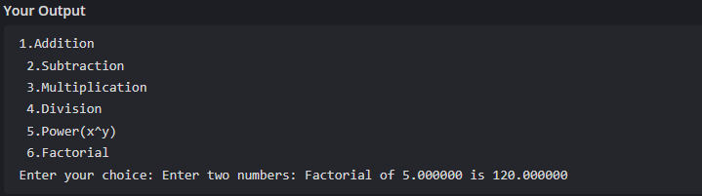

CONCLUSION:
Thus, a simple calculator program was successfully implemented using C programming. The program demonstrates the use of switch-case statements, loops, and arithmetic operations.

FAQs:
- What is a simple calculator program?
- Why is switch–case preferred in calculator programs?
- How does the program handle division by zero?
- How is the power operation (xʸ) implemented without using math library functions?
- What is factorial and how is it calculated using loops in C?

